EXPERIMENT 4
ROLL NO: 240701533 NAME: SRITHIKA

Design an application layout using different colors, text styles, and visual elements. Share the design with users through a Google Form or any other feedback collection method to gather their responses. Based on the feedback received, refine and improve the design accordingly.
Screen 01:
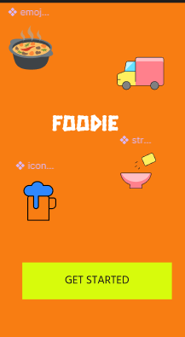
Prototype:
https://www.figma.com/design/m0HQMKrgyKcmFK1nSLieen/Untitled?node-id=42-5
Top Icons (Visual Theme)
- You have small food and delivery-related icons:
  - Bowl of food
  - Delivery truck
  - Cooking pot
- These icons visually tell the user:
“This app is about food / ordering / cooking”
Title – “FOODIE”
- Placed at the center
- Styled with a bold, playful font
- Acts as the app name or brand identity
screen 02:
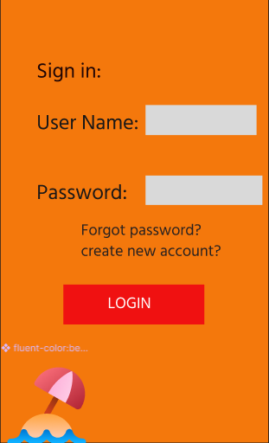
📝 Title Section
- “Sign in:” appears at the top
- Clearly tells the user what to do
- Simple and easy to understand
👉 You could center it or make it bold for better visibility.

📥 Input Fields
- User Name field → for entering username/email
- Password field → for secure login
Design details:
- Light grey boxes show where to type
- Clean and minimal look
- Good spacing between fields
👉 Improvements:
- Add placeholder text like “Enter your username”
- Add password hide/show icon 👁️

🔁 Help Options
- “Forgot password?” → helps users recover their account
- “Create new account?” → for new users to sign up
👉 These improve user experience by giving alternatives if login fails.

🔴 Login Button
- Bright red “LOGIN” button
- Clearly stands out against orange background
- Acts as the main action (CTA)
👉 You can:
- Add rounded corners
- Add shadow for a modern look

🎨 Design & Visual Elements
- Orange background → energetic, food-related vibe 🍔
- Small beach/umbrella icon → decorative element
- Simple layout → beginner-friendly design

📱 Overall Purpose
This screen:
- Collects user credentials
- Provides help options
- Guides user into the app
👉 It is typically the second screen after the welcome screen.

👍 What’s Good
- Simple and easy to understand
- Clear flow (input → action)
- Good color contrast
Prototype link:
https://www.figma.com/design/m0HQMKrgyKcmFK1nSLieen/Untitled?node-id=42-58

SCREEN:03
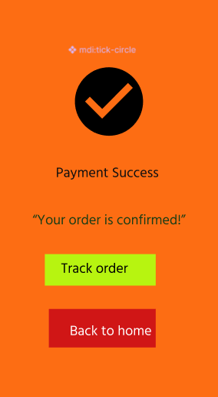
✔️ Success Icon
- Big checkmark inside a circle
- Universally represents success / completed action
- Immediately tells user: ✔️ payment done

📝 Message Section
- “Payment Success” → main heading
- “Your order is confirmed!” → supportive message
👉 Reassures the user that everything worked correctly

🟩 Track Order Button
- Bright green button
- Action: lets user track delivery status 🚚
👉 Important next step after ordering

🔴 Back to Home Button
- Red button
- Action: takes user back to home screen
👉 Gives user option to continue browsing

🎨 Design Elements
- Orange background → consistent with app theme
- Simple layout → easy to understand
- Clear hierarchy → icon → message → actions

📱 Purpose of This Screen
- Confirms payment success
- Reduces user anxiety
- Provides next actions (track or go home)

👍 What’s Good
- Clear success indication
- Easy navigation options
- Beginner-friendly design

🔧 Improvements You Can Try
- Add order details (Order ID, time, amount)
- Add small animation (tick bounce)
- Use softer colors for better balance
- Add estimated delivery time
Prototype link:
https://www.figma.com/design/m0HQMKrgyKcmFK1nSLieen/Untitled?node-id=43-77

google form link:
https://share.google/HCSGBvFJVZ6ZSya1d

